ICP 5 - 3 Unit 2 Maths – Adding, Subtracting and Partitioning Numbers

Name |  | Class
Teacher |  | Date

Part A: Additive number facts
- __________ | 6. __________ | 11. __________ | 16. __________
- __________ | 7. __________ | 12. __________ | 17. __________
- __________ | 8. __________ | 13. __________ | 18. __________
- __________ | 9. __________ | 14. __________ | 19. __________
- __________ | 10. __________ | 15. __________ | 20. __________

Part B: Place value understanding
- Dale’s calculator showed the following number: 
What would Dale do to change 796 to become … 
- Circle your answer:
Add 100 | Add 10 | Add 14 | Take away 90 | Take away 190
- Explain your choice:
- How many hundreds are there in the number 702?
- On the number expander, write how many tens and ones the number 952 has altogether.
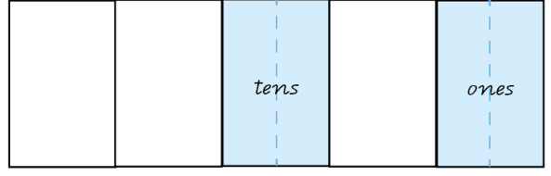
- How many hundreds are there in the number 952?
- What number is 10 less than 952?
- Write the number that has 34 tens only.
Part C: Problem-solving
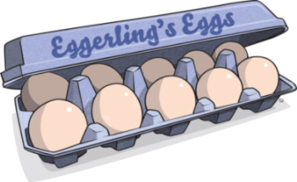
1. Eggerling’s Organic Eggs sell their eggs in cartons of 10.
Mini Eggerling, the owner, collected 234 eggs.
How many cartons did she use to pack her eggs?
- Show your working:
- Number of cartons
2. There are 213 cartons in the Eggerling’s van.
There are three shops.
Ten cartons are delivered to each shop.
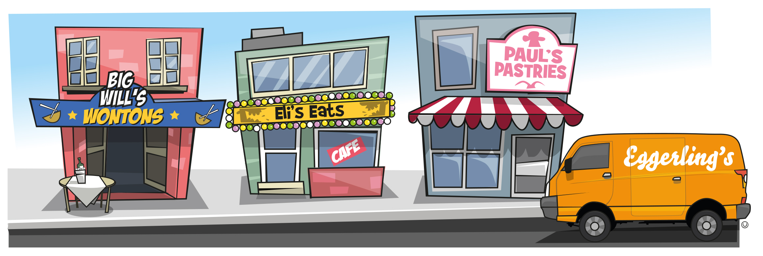
How many cartons are left in the van after the delivery to shop three?
- Show your working:
b) … cartons are left in the van.

Year 3 Mathematics: Unit 2 — Adding, subtracting and partitioning numbers | Name:
Purpose of assessment: To recall addition and subtraction facts and apply place value understanding to partition, rearrange and regroup numbers.
Understanding and Fluency |  |  |  | Problem-solving and Reasoning
Recall addition facts and related subtraction facts.  Recognise equivalent representations for the same number. |  |  |  | Partition, regroup and rearrange numbers to solve problems.
 |  | Writes 34 tens as an equivalent value. |  |  |  | Partitions and regroups numbers to solve all problems and clearly explains thinking. | A
 |  | Represents three-digit number 952 on a number expander and identifies the digit in the hundreds place. |  |  |  | Partitions and regroups numbers to determine the total number of cartons or the number that is the total number of cartons left in the van and records thinking. | B
 |  | Recalls addition and subtraction number facts.  Represents 952 on a number expander.  Counts forwards and backwards by 10 involving three digit numbers. |  |  |  | Explains how Dale changed the value of the number 796 to 806.  Correctly calculates the total number of egg cartons or the number that is the total number of cartons left in the van. | C
 |  | Reads a three-digit number and identifies the digit in the hundreds place. |  |  |  | Identifies the total number of cartons delivered to all three shops. | D
 |  | Recalls an addition or subtraction number fact. |  |  |  | Writes a number or number sentence. | E

Feedback:

